

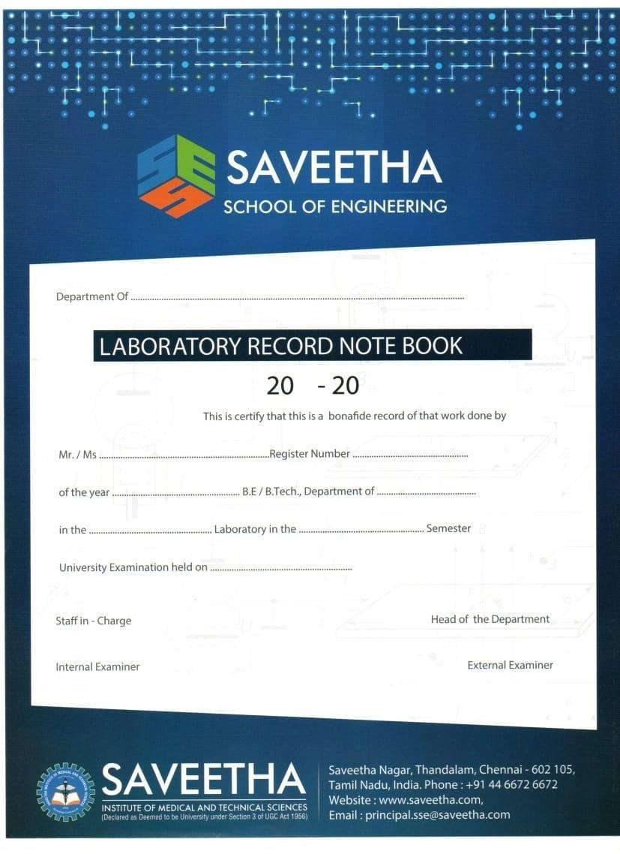

## SAVEETHA INSTITUTE OF MEDICAL AND TECHNICAL SCIENCES

|  |  |  |  |  |  |
| --- | --- | --- | --- | --- | --- |
| Exp.No | Date | Title | Page no. | Marks | Sign |
| 1 | 22.01.24 | Python program to solve 8-Puzzle problem. |  |  |  |
| 2 | 22.01.24 | Python program to solve 8-Queen problem. |  |  |  |
| 3 | 22.01.24 | Python program to implement BFS. |  |  |  |
| 4 | 22.01.24 | Python program to implement DFS. |  |  |  |
| 5 | 23.01.24 | Python to implement Travelling Salesman Problem. |  |  |  |
| 6 | 23.01.24 | Python program to implement Minimax Algorithm. |  |  |  |
| 7 | 23.01.24 | Python program to implement Decision Tree. |  |  |  |
| 8 | 23.01.24 | Python program to implement Feed forward neural Network. |  |  |  |
| 9 | 24.01.24 | Prolog program to implement family tree. |  |  |  |
| 10 | 24.01.24 | Prolog program to implement factorial. |  |  |  |
| 11 | 24.01.24 | Prolog program to implement Finding GCD of two numbers. |  |  |  |
| 12 | 24.01.24 | Write the prolog program for Working with Lists:   1. Printing all elements of a list. 2. To append an integer into the list. 3. List Membership. |  |  |  |
| 13 | 25.01.24 | Prolog program for Medical Diagnosis. |  |  |  |

INDEX

Date: 8-PUZZLE PROBLEM

Ex. No: 1

AIM:

To write a python program to implement 8(eight) puzzle problem.

ALGORITHM:

STEP 1: Start the program.

STEP 2: Get the current state of the scenario (refers to the board or game in real world).

STEP 3: Find the available moves and their cost.

STEP 4: Choose the move with the least cost and set it as the current state. STEP 5: Check if it matches the goal state, if yes terminate, if no move to step 2. STEP 6: Compile and execute the program.

STEP 7: Print the result.

STEP 8: End.

PROGRAM:

class Node:

def __init__(self,data,level,fval):

""" Initialize the node with the data, level of the node and the calculated fvalue """

self.data = data

self.level = level

self.fval = fval

def generate_child(self):

""" Generate child nodes from the given node by moving the blank space

either in the four directions {up,down,left,right} """

x,y = self.find(self.data,'_')

""" val_list contains position values for moving the blank space in either of

the 4 directions [up,down,left,right] respectively. """

val_list = [[x,y-1],[x,y+1],[x-1,y],[x+1,y]]

children = []

for i in val_list:

child = self.shuffle(self.data,x,y,i[0],i[1])

if child is not None:

child_node = Node(child,self.level+1,0)

children.append(child_node)

return children

def shuffle(self,puz,x1,y1,x2,y2):

""" Move the blank space in the given direction and if the position value are out

of limits the return None """

if x2 >= 0 and x2 < len(self.data) and y2 >= 0 and y2 < len(self.data):

temp_puz = []

temp_puz = self.copy(puz)

temp = temp_puz[x2][y2]

temp_puz[x2][y2] = temp_puz[x1][y1]

temp_puz[x1][y1] = temp

return temp_puz

else:

return None

def copy(self,root):

""" Copy function to create a similar matrix of the given node"""

temp = []

for i in root:

t = []

for j in i:

t.append(j)

temp.append(t)

return temp

def find(self,puz,x):

""" Specifically used to find the position of the blank space """

for i in range(0,len(self.data)):

for j in range(0,len(self.data)):

if puz[i][j] == x:

return i,j

class Puzzle:

def __init__(self,size):

""" Initialize the puzzle size by the specified size,open and closed lists to empty """

self.n = size

self.open = []

self.closed = []

def accept(self):

""" Accepts the puzzle from the user """

puz = []

for i in range(0,self.n):

temp = input().split(" ")

puz.append(temp)

return puz

def f(self,start,goal):

""" Heuristic Function to calculate hueristic value f(x) = h(x) + g(x) """

return self.h(start.data,goal)+start.level

def h(self,start,goal):

""" Calculates the different between the given puzzles """

temp = 0

for i in range(0,self.n):

for j in range(0,self.n):

if start[i][j] != goal[i][j] and start[i][j] != '_':

temp += 1

return temp

def process(self):

""" Accept Start and Goal Puzzle state"""

print("Enter the start state matrix \n")

start = self.accept()

print("Enter the goal state matrix \n")

goal = self.accept()

start = Node(start,0,0)

start.fval = self.f(start,goal)

""" Put the start node in the open list"""

self.open.append(start)

print("\n\n")

while True:

cur = self.open[0]

print("")

print(" | ")

print(" | ")

print(" \\\'/ \n")

for i in cur.data:

for j in i:

print(j,end=" ")

print("")

""" If the difference between current and goal node is 0 we have reached the goal node"""

if(self.h(cur.data,goal) == 0):

break

for i in cur.generate_child():

i.fval = self.f(i,goal)

self.open.append(i)

self.closed.append(cur)

del self.open[0]

""" sort the opne list based on f value """

self.open.sort(key = lambda x:x.fval,reverse=False)

puz = Puzzle(3)

puz.process()

OUTPUT:

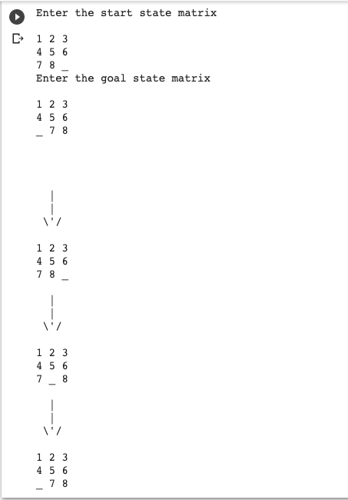

RESULT:

Therefore, the above program to implement 8 puzzle problem is compiled and executed successfully.

Date: 8-QUEEN PROBLEM

Ex. No: 2

AIM:

To write a python program to implement 8(eight) Queen problem.

ALGORITHM:

STEP 1: Start the program.

STEP 2: Start by placing the first queen on the top-left square of the chessboard.

STEP 3: If we have placed the 8 queens, we’re done. Otherwise, is it possible to place a another queen in a safe position?

STEP 4: If yes, then mark this [row, column] as part of the solution, and go back to point 3.

END CIENCES STEP 5: If no, then change the position of the previous queen (backtracking) and go back to point 3.

STEP 6: Compile and execute the program.

STEP 7: Print the result.

STEP 8: End

PROGRAM:

class NQueens:

"""Generate all valid solutions for the n queens puzzle"""

def __init__(self, size):

# Store the puzzle (problem) size and the number of valid solutions

self.size = size

self.solutions = 0

self.solve()

def solve(self):

"""Solve the n queens puzzle and print the number of solutions"""

positions = [-1] * self.size

self.put_queen(positions, 0)

print("Found", self.solutions, "solutions.")

def put_queen(self, positions, target_row):

"""

Try to place a queen on target_row by checking all N possible cases.

If a valid place is found the function calls itself trying to place a queen

on the next row until all N queens are placed on the NxN board.

"""

# Base (stop) case - all N rows are occupied

if target_row == self.size:

self.show_full_board(positions)

# self.show_short_board(positions)

self.solutions += 1

else:

# For all N columns positions try to place a queen

for column in range(self.size):

# Reject all invalid positions

if self.check_place(positions, target_row, column):

positions[target_row] = column

self.put_queen(positions, target_row + 1)

def check_place(self, positions, ocuppied_rows, column):

"""

Check if a given position is under attack from any of

the previously placed queens (check column and diagonal positions)

"""

for i in range(ocuppied_rows):

if positions[i] == column or \

positions[i] - i == column - ocuppied_rows or \

positions[i] + i == column + ocuppied_rows:

return False

return True

def show_full_board(self, positions):

"""Show the full NxN board"""

for row in range(self.size):

line = ""

for column in range(self.size):

if positions[row] == column:

line += "Q "

else:

line += ". "

print(line)

print("\n")

def show_short_board(self, positions):

"""

Show the queens positions on the board in compressed form,

each number represent the occupied column position in the corresponding row.

"""

line = ""

for i in range(self.size):

line += str(positions[i]) + " "

print(line)

def main():

"""Initialize and solve the n queens puzzle"""

n=int(input("Enter the n value:"))

NQueens(n)

if __name__ == "__main__":

# execute only if run as a script

main()

OUTPUT:

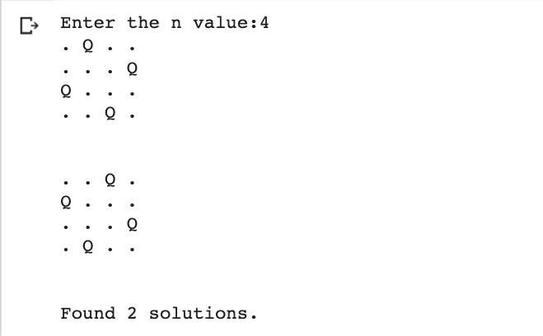

RESULT: Therefore, the above program to implement 8 Queen problem is compiled and executed successfully.

Date: BREADTH FIRST SEARCH (BFS )

Ex. No: 3

AIM:

To write a python program to implement Breadth First Search Algorithm.

ALGORITHM:

STEP 1: Start the program.

STEP 2: Start by putting any one of the graph’s vertices at the back of the queue.

STEP 3: Now take the front item of the queue and add it to the visited list.

STEP 4: Create a list of that vertex's adjacent nodes.

STEP 5: Add those which are not within the visited list to the rear of the queue

STEP 6: Keep continuing steps two and three till the queue is empty.

STEP 7: Compile and execute the program.

STEP 8: Print the result.

STEP 9: End.

**PROGRAM:**

graph = {

'5' : ['3','7'],

'3' : ['2', '4'],

'7' : ['8'],

'2' : [],

'4' : ['8'],

'8' : []

}

visited = [] # List for visited nodes.

queue = [] #Initialize a queue

def bfs(visited, graph, node): #function for BFS

visited.append(node)

queue.append(node)

while queue: # Creating loop to visit each node

m = queue.pop(0)

print (m, end = " ")

for neighbour in graph[m]:

if neighbour not in visited:

visited.append(neighbour)

queue.append(neighbour)

# Driver Code

print("Following is the Breadth-First Search")

bfs(visited, graph, '5') # function calling

OUTPUT:



RESULT:

Therefore, the above program to implement Breadth First Search Algorithm is compiled and executed successful

Date: DEPTH FIRST SEARCH (DFS )

Ex. No: 4

AIM:

To write a python program to implement Depth First Search Algorithm.

ALGORITHM:

STEP 1: Start the program.

STEP 2: We will start by putting any one of the graph's vertex on top of the stack.

STEP 3: After that take, the top item of the stack and add it to the visited list of the vertex.

STEP 4: Next, create a list of that adjacent node of the vertex.

STEP 5: Add the ones which are not in the visited list of vertexes to the top of the stack.

STEP 6: Lastly, keep repeating steps 3, 4 and 5 until the stack is empty.

STEP 7: Compile and execute the program.

STEP 8: Print the result.

STEP 9: End.

PROGRAM:

# Using a Python dictionary to act as an adjacency list

graph = {

'A' : ['B','C'],

'B' : ['D', 'E'],

'C' : ['F'],

'D' : [],

'E' : ['F'],

'F' : []

}

visited = set() # Set to keep track of visited nodes.

def dfs(visited, graph, node):

if node not in visited:

print (node)

visited.add(node)

for neighbour in graph[node]:

dfs(visited, graph, neighbour)

# Driver Code

dfs(visited, graph, ‘A')

OUTPUT: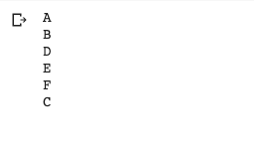

RESULT: Therefore, the above program to implement Depth First Search Algorithm is compiled and executed successfully.

Date: TRAVELLING SALESMAN PROBLEM

Ex. No: 5

AIM:

To write a python program to implement Travelling Salesman Problem.

ALGORITHM:

STEP 1: Start the program.

STEP 2: Consider city 1 as the starting and ending point.

STEP 3: Since the route is cyclic, we can consider any point as a starting point.

STEP 4: Generate all (n-1)! permutations of cities.

STEP 5: Calculate the cost of every permutation and keep track of the minimum cost permutation.

STEP 6: Return the permutation with minimum cost.

STEP 7: Compile and execute the program.

STEP 8: Print the result.

STEP 9: End.

PROGRAM:

# Python3 program to implement traveling salesman

# problem using naive approach.

from sys import maxsize

from itertools import permutations

V = 4

# implementation of traveling Salesman Problem

def travellingSalesmanProblem(graph, s):

# store all vertex apart from source vertex

vertex = []

for i in range(V):

if i != s:

vertex.append(i)

# store minimum weight Hamiltonian Cycle

min_path = maxsize

next_permutation=permutations(vertex)

for i in next_permutation:

# store current Path weight(cost)

current_pathweight = 0

# compute current path weight

k = s

for j in i:

current_pathweight += graph[k][j]

k = j

current_pathweight += graph[k][s]

# update minimum

min_path = min(min_path, current_pathweight)

return min_path

# Driver Code

if __name__ == "__main__":

# matrix representation of graph

graph = [[0, 10, 15, 20], [10, 0, 35, 25],

[15, 35, 0, 30], [20, 25, 30, 0]]

s = 0

print(travellingSalesmanProblem(graph, s))

OUTPUT:



RESULT: Therefore, the above program to implement Travelling Salesman Problem is compiled and executed successfully.

Date: MINIMAX ALGORITHM

Ex. No: 6

AIM:

To write a python program to implement Min-Max Algorithm.

ALGORITHM:

STEP 1: Start the program

STEP 2: Minimax is a kind of [backtracking](https://www.geeksforgeeks.org/tag/backtracking/) algorithm that is used in decision making and game theory to find the optimal move for a player, assuming that your opponent also plays optimally.

STEP 3: It is widely used in two player turn-based games such as Tic-Tac-Toe, Backgammon, Mancala, Chess, etc.

STEP 4: In Minimax the two players are called maximizer and minimizer.

STEP 5: Maximizer goes LEFT: It is now the minimizers turn. The minimizer now has a choice between 3 and 5. Being the minimizer it will choose the least among both, that is 3

STEP 6: Maximizer goes RIGHT: It is now the minimizers turn. The minimizer now has a choice between 2 and 9. He will choose 2 as it is the least among the two values.

STEP 7: Being the maximizer, you would choose the larger value

STEP 8: Compile and execute the program.

STEP 9: Print the result.

STEP 10: End.

**PROGRAM:**

# A simple Python3 program to find

# maximum score that

# maximizing player can get

import math

def minimax (curDepth, nodeIndex,

maxTurn, scores,

targetDepth):

# base case : targetDepth reached

if (curDepth == targetDepth):

return scores[nodeIndex]

if (maxTurn):

return max(minimax(curDepth + 1, nodeIndex * 2,

False, scores, targetDepth),

minimax(curDepth + 1, nodeIndex * 2 + 1,

False, scores, targetDepth))

else:

return min(minimax(curDepth + 1, nodeIndex * 2,

True, scores, targetDepth),

minimax(curDepth + 1, nodeIndex * 2 + 1,

True, scores, targetDepth))

# Driver code

scores = [3, 5, 2, 9, 12, 5, 23, 23]

treeDepth = math.log(len(scores), 2)

print("The optimal value is : ", end = "")

print(minimax(0, 0, True, scores, treeDepth))

# This code is contributed

# by rootshadow

OUTPUT:

RESULT: Therefore, the above program to implement Min-Max Algorithm is compiled and executed successfully.

Date: DECISION TREE

Ex. No: 7

AIM:

To write a python program to implement Decision Tree.

ALGORITHM:

STEP 1: Start the program. STEP 2: Load required packages. STEP 3: Load the dataset.

STEP 4: Visualize the dataset using a graph.

STEP 5: Define the features and the target. STEP 6: Split the dataset and test sets.

STEP 7: Build the model with the decision tree.

STEP 8: Compile and execute the program.

STEP 9: Print the result.

STEP 10: End.

PROGRAM:

# Run this program on your local python

# interpreter, provided you have installed

# the required libraries.

# Importing the required packages

import numpy as np

import pandas as pd

from sklearn.metrics import confusion_matrix

from sklearn.model_selection import train_test_split

from sklearn.tree import DecisionTreeClassifier

from sklearn.metrics import accuracy_score

from sklearn.metrics import classification_report

# Function importing Dataset

def importdata():

balance_data = pd.read_csv(

'https://archive.ics.uci.edu/ml/machine-learning-'+

'databases/balance-scale/balance-scale.data',

sep= ',', header = None)

# Printing the dataswet shape

print ("Dataset Length: ", len(balance_data))

print ("Dataset Shape: ", balance_data.shape)

# Printing the dataset obseravtions

print ("Dataset: ",balance_data.head())

return balance_data

# Function to split the dataset

def splitdataset(balance_data):

# Separating the target variable

X = balance_data.values[:, 1:5]

Y = balance_data.values[:, 0]

# Splitting the dataset into train and test

X_train, X_test, y_train, y_test = train_test_split(

X, Y, test_size = 0.3, random_state = 100)

return X, Y, X_train, X_test, y_train, y_test

# Function to perform training with giniIndex.

def train_using_gini(X_train, X_test, y_train):

# Creating the classifier object

clf_gini = DecisionTreeClassifier(criterion = "gini",

random_state = 100,max_depth=3, min_samples_leaf=5)

# Performing training

clf_gini.fit(X_train, y_train)

return clf_gini

# Function to perform training with entropy.

def tarin_using_entropy(X_train, X_test, y_train):

# Decision tree with entropy

clf_entropy = DecisionTreeClassifier(

criterion = "entropy", random_state = 100,

max_depth = 3, min_samples_leaf = 5)

# Performing training

clf_entropy.fit(X_train, y_train)

return clf_entropy

# Function to make predictions

def prediction(X_test, clf_object):

# Predicton on test with giniIndex

y_pred = clf_object.predict(X_test)

print("Predicted values:")

print(y_pred)

return y_pred

# Function to calculate accuracy

def cal_accuracy(y_test, y_pred):

print("Confusion Matrix: ",

confusion_matrix(y_test, y_pred))

print ("Accuracy : ",

accuracy_score(y_test,y_pred)*100)

print("Report : ",

classification_report(y_test, y_pred))

# Driver code

def main():

# Building Phase

data = importdata()

X, Y, X_train, X_test, y_train, y_test = splitdataset(data)

clf_gini = train_using_gini(X_train, X_test, y_train)

clf_entropy = tarin_using_entropy(X_train, X_test, y_train)

# Operational Phase

print("Results Using Gini Index:")

# Prediction using gini

y_pred_gini = prediction(X_test, clf_gini)

cal_accuracy(y_test, y_pred_gini)

print("Results Using Entropy:")

# Prediction using entropy

y_pred_entropy = prediction(X_test, clf_entropy)

cal_accuracy(y_test, y_pred_entropy)

# Calling main function

if __name__=="__main__":

main()

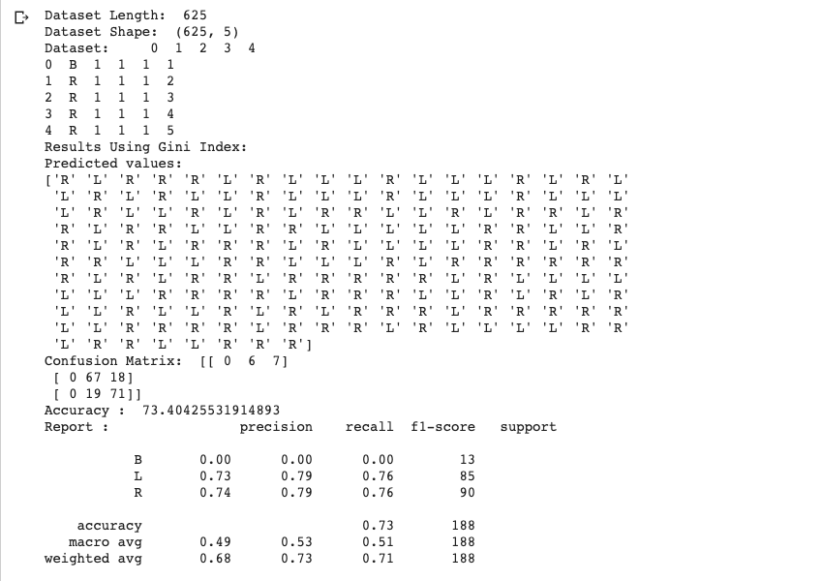OUTPUT: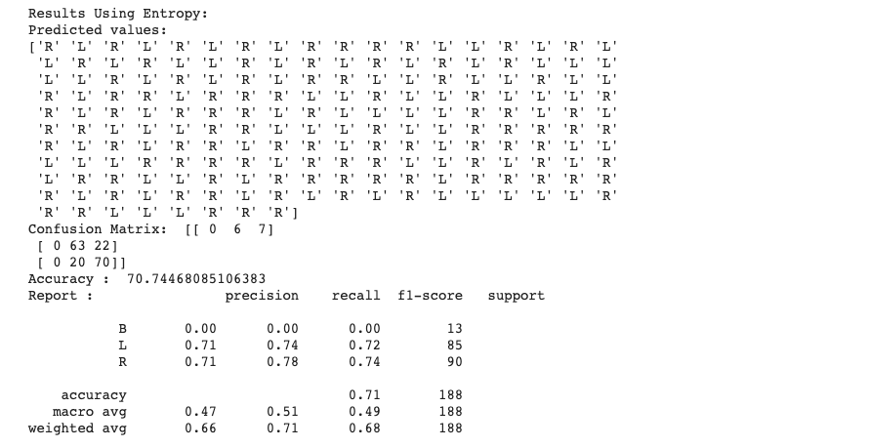

RESULT: Therefore, the above program to implement Decision Tree is compiled and executed successfully

Date: NEURAL NETWORK

Ex. No: 8

AIM:

To write a python program to implement Feed forward and neural network.

ALGORITHM:

STEP 1: Start the program.

STEP 2: Create sample weights to be applied in the input layer, first hidden layer and the second hidden layer.

STEP 3: The weight for each layer is created as matrix of size M x N where M represents the number of neurons in the layer and N represents number of nodes / neurons in the next layer.

STEP 4: Weighted sum is calculated for neurons at every layer.

STEP 5: weighted sum is sum of weights and input signal combined with the bias element.

STEP 6: SoftMax function is applied to the output in the last layer.

STEP 7: Compile and execute the program.

STEP 8: Print the result.

STEP 9: End.

PROGRAM:

import numpy as np

class NeuralNetwork():

def __init__(self):

# seeding for random number generation

np.random.seed(1)

#converting weights to a 3 by 1 matrix with values from -1 to 1 and mean of 0

self.synaptic_weights = 2 * np.random.random((3, 1)) - 1

def sigmoid(self, x):

#applying the sigmoid function

return 1 / (1 + np.exp(-x))

def sigmoid_derivative(self, x):

#computing derivative to the Sigmoid function

return x * (1 - x)

def train(self, training_inputs, training_outputs, training_iterations):

#training the model to make accurate predictions while adjusting weights continually

for iteration in range(training_iterations):

#siphon the training data via the neuron

output = self.think(training_inputs)

#computing error rate for back-propagation

error = training_outputs - output

#performing weight adjustments

adjustments = np.dot(training_inputs.T, error * self.sigmoid_derivative(output))

self.synaptic_weights += adjustments

def think(self, inputs):

#passing the inputs via the neuron to get output

#converting values to floats

inputs = inputs.astype(float)

output = self.sigmoid(np.dot(inputs, self.synaptic_weights))

return output

if __name__ == "__main__":

#initializing the neuron class

neural_network = NeuralNetwork()

print("Beginning Randomly Generated Weights: ")

print(neural_network.synaptic_weights)

#training data consisting of 4 examples--3 input values and 1 output

training_inputs = np.array([[0,0,1],

[1,1,1],

[1,0,1],

[0,1,1]])

training_outputs = np.array([[0,1,1,0]]).T

#training taking place

neural_network.train(training_inputs, training_outputs, 15000)

print("Ending Weights After Training: ")

print(neural_network.synaptic_weights)

user_input_one = str(input("User Input One: "))

user_input_two = str(input("User Input Two: "))

user_input_three = str(input("User Input Three: "))

print("Considering New Situation: ", user_input_one, user_input_two, user_input_three)

print("New Output data: ")

print(neural_network.think(np.array([user_input_one, user_input_two, user_input_three])))

print("Wow, we did it!")

OUTPUT :

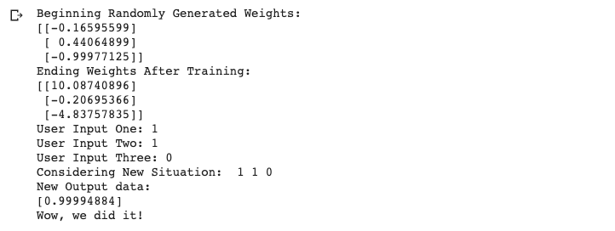 RESULT:Therefore, the above program to implement Feed forward and neural network is compiled and executed successfully

Date: PROLOG PROGRAM FOR FAMILY TREE

Ex. No: 9

AIM:

To write a prolog program to implement Family Tree.

ALGORITHM:

STEP 1: Start the program.

STEP 2: Declare the facts and rules for family tree.

STEP 3: Perform suitable operations.

STEP 4: Post Queries related to the given problem in the Query box.

STEP 5: Compile and execute the program.

STEP 6: Get the answers for the queries asked and print the result.

STEP 7: End.

PROGRAM:

female(vasundhara).

female(padmavathamma).

female(nikitha).

female(aarthi).

male(narayana).

male(prakash).

male(raju).

parent(narayana,prakash).

parent(padmavathamma,prakash).

parent(prakash,nikitha).

parent(vasundhara,nikitha).

parent(prakash,aarthi).

parent(vasundhara,aarthi).

parent(prakash,raju).

parent(vasundhara,raju).

mother(X,Y):- parent(X,Y),female(X).

father(X,Y):-parent(X,Y),male(X).

sister(X,Y):-parent(Z,X),parent(Z,Y),female(X),X\==Y.

brother(X,Y):-parent(Z,X),parent(Z,Y),male(X),X\==Y.

grandparent(X,Y):-parent(X,Z),parent(Z,Y).

grandmother(X,Z):-mother(X,Y),parent(Y,Z).

grandfather(X,Z):-father(X,Y),parent(Y,Z).

wife(X,Y):-parent(X,Z),parent(Y,Z),female(X),male(Y).

OUTPUT:

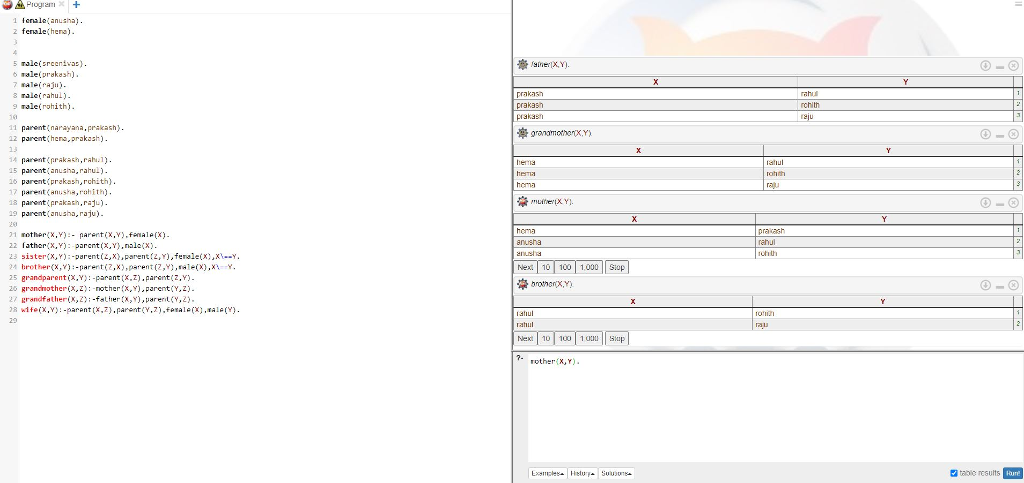

RESULT:



Date: PROLOG PROGRAM FOR GETTING INPUT

AND PROCESSING OUTPUT

Ex. No: 10(A)

A).PROCESSING NUMBERS: CALCULATING FACTORIAL

AIM:

To write a prolog program to implement Factorial.

ALGORITHM:

STEP 1: Start the program

STEP 2: Enter the integer as X.

STEP 3: Initialize A=1

STEP 4: If X=0, then print Factorial of A.

STEP 5: If X! =0, (ie) =B, then perform Factorial of B and print the result.

STEP 6: End.

PROGRAM:

fact(0,1).

fact(N,F) :-

( % the below is for +ve factorial N > 0->

( N1 is N - 1,

fact(N1,F1),

F is N*F1);

% The below is for -ve factorial

N<0-> ( N1 is N+1,fact(N1,F1),F is N*F1)).

OUTPUT:

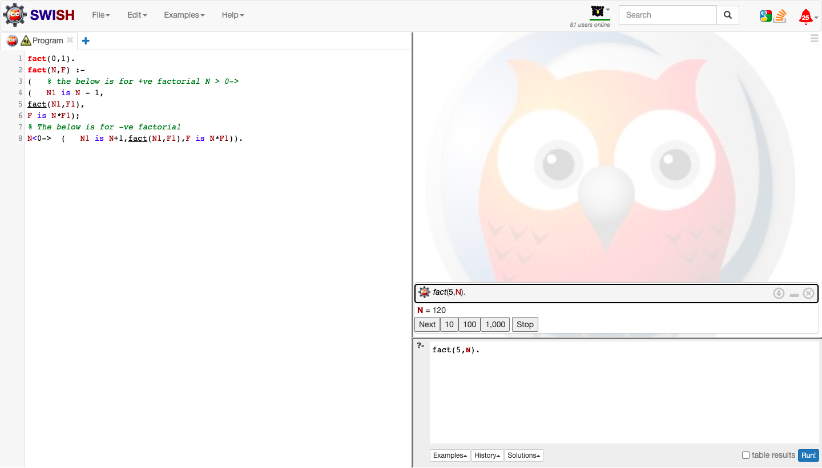

Date: PROLOG PROGRAM FOR GETTING INPUT

AND PROCESSING OUTPUT

Ex. No: 10(B)

B).GCD OF TWO NUMBERS

AIM:

To write a prolog program to implement GCD of Two numbers.

ALGORITHM:

STEP 1: Start the program. Get input for the two numbers

STEP 2: Declare the facts and rules for GCD of two numbers.

STEP 3: Perform suitable operations.

STEP 4: Post Queries related to the given problem in the Query box.

STEP 5: Compile and execute the program.

STEP 6: Get the answers for the queries asked and print the result.

STEP 7: End

PROGRAM:

gcd(X,Y):-X=Y,write('GCD of two numbers is '),write(X);

X=0,write('GCD of two numbers is '),write(Y);

Y=0,write('GCD of two numbers is '),write(X);

Y>X,Y1 is Y-X,gcd(X,Y1);

X>Y,Y1 is X-Y,gcd(Y1,Y).

OUTPUT:

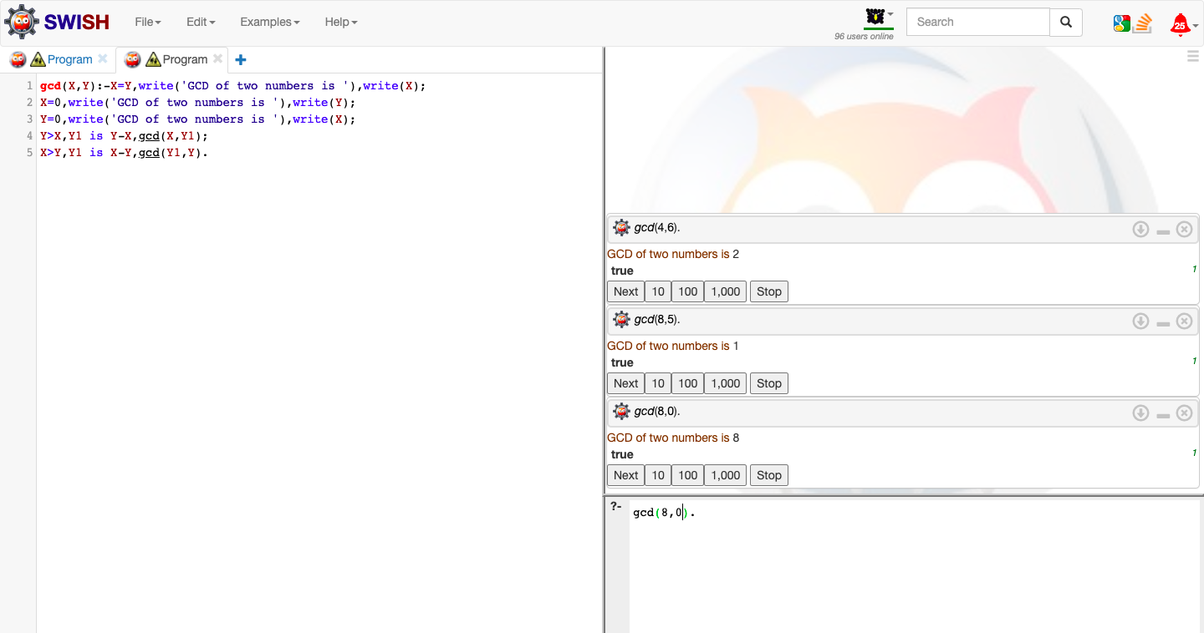

Date: PROLOG PROGRAM-WORKING WITH LISTS

Ex. No: 11(A)

A)PRINTING ALL ELEMENTS OF A LIST

AIM :

To write a prolog program to implement List and perform given operations to print list, append list and to check whether a member is present or not in the list.

ALGORITHM:

STEP 1: Start the program. Get inputs.

STEP 2: Declare the facts and rules for List.

STEP 3: Perform suitable operations.

STEP 4: Post Queries related to the given problem in the Query box.

STEP 5: Compile and execute the program.

STEP 6: Get the answers for the queries asked and print the result.

STEP 7: End

PROGRAM:

printlist([]).

printlist([X|List]) :- write(X),nl, printlist(List).

OUTPUT:

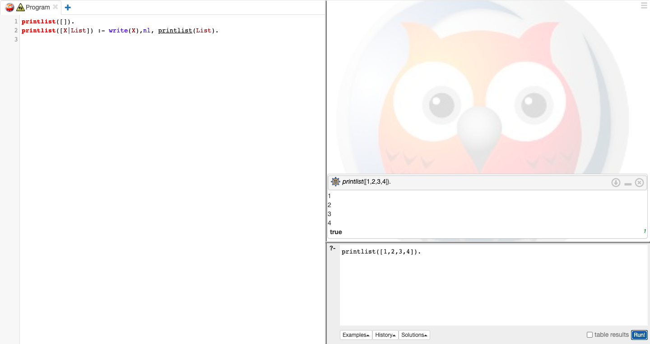

Date: PROLOG PROGRAM-WORKING WITH LISTS

Ex. No: 11(B)

B)TO APPEND AN INTEGER INTO THE LIST

PROGRAM:

append([],L,L).

append([X|L1],L2,[X|L3]) :- append(L1,L2,L3).

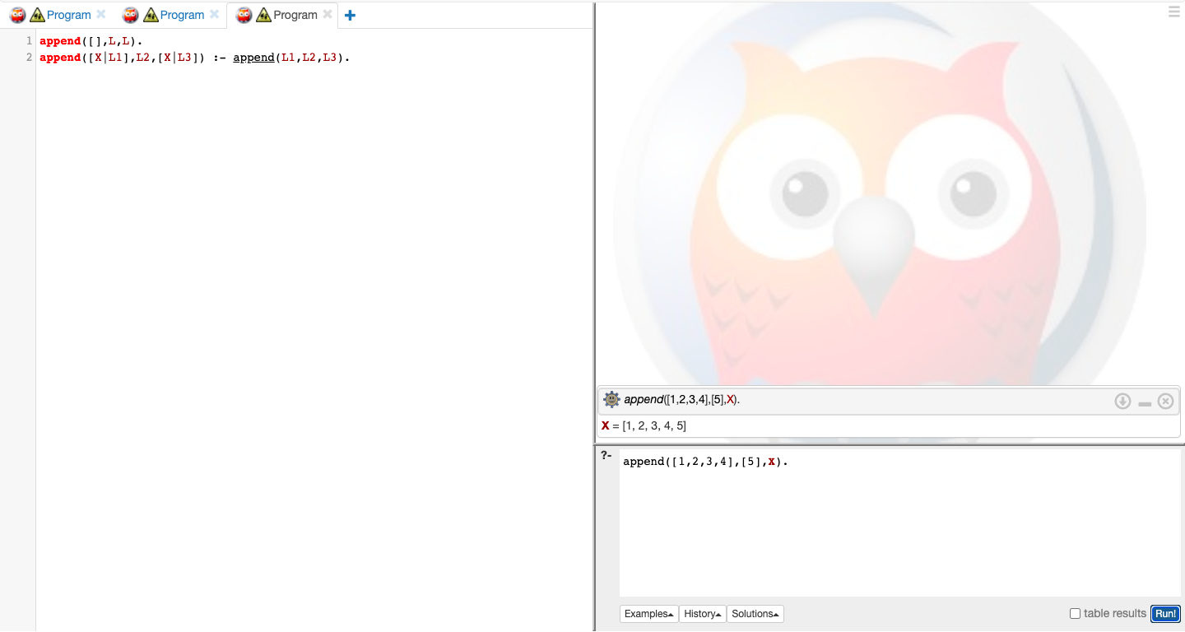OUTPUT:

Date: PROLOG PROGRAM-WORKING WITH LISTS

Ex. No: 11(C)

C) LIST MEMBERSHIP

PROGRAM:

member(X,List):- delete(X,List,_).

delete(X,[X|Tail],Tail). delete(X,[Y|Tail1],[Y|Tail2]):-

delete(X,Tail1,Tail2).

OUTPUT:

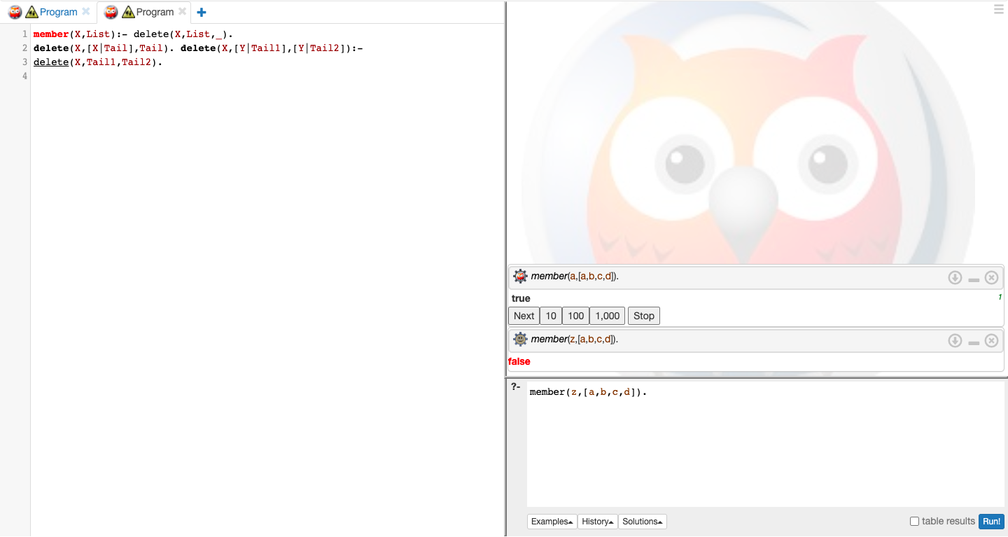

RESULT : Therefore, the above prolog program to implement List is compiled and executed successfully.

Date: PROLOG PROGRAM FOR MEDICAL DIAGNOSIS

Ex. No: 12

AIM:

To write a prolog program to implement Medical Diagnosis System.

ALGORITHM:

STEP 1: Start the program. Get inputs.

STEP 2: Declare the facts and rules for Medical Diagnosis System.

STEP 3: Perform suitable operations.

STEP 4: Post Queries related to the given problem in the Query box.

STEP 5: Compile and execute the program.

STEP 6: Get the answers for the queries asked and print the result.

STEP 7: End

PROGRAM:

domains disease,indication,name=symbol predicates

hypothesis(name,disease) symptom(name,indication)

clauses

symptom(yamini,fever). symptom(yamini,rash) . symptom(yamini,headache). symptom(yamini,runn_nose). symptom(hemanth,chills). symptom(hemanth,fever). symptom(hemnth,headache). symptom(radhika,runny_nose). symptom(radhika,rash). symptom(radhika,flu). hypothesis(Patient,measels): symptom(Patient,fever), symptom(Patient,cough), symptom(Patient,conjunctivitis), symptom(Patient,r ash). hypothesis(Patient,german_measl es): symptom(Patient,f ev er ), symptom(Patient,headache), symptom(Patient,runny_nose), symptom(Patient,rash).

OUTPUT:

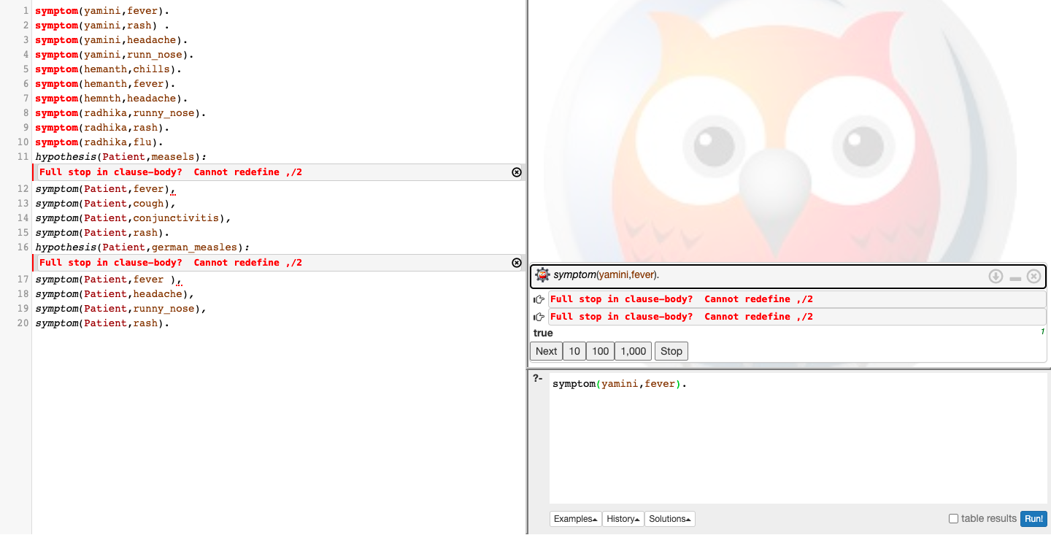

RESULT:

Therefore, the above prolog program to implement Medical Diagnosis System is compiled and executed successfully.